Chapter 6, Problem 74.

The triangular waveform in Fig. 6.91(a) is applied to the input of the op amp differentiator in Fig. 6.91(b). Plot the output.

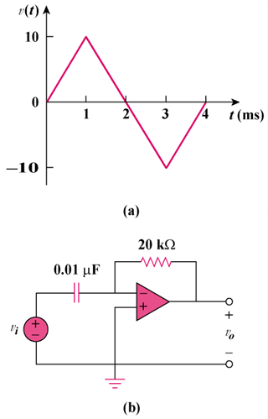

Figure 6.91
For Prob. 6.74.

